**Coronavirus Information System**

**Class:- XII-B**

**Submitted To:-**

**Rachana Ma’am**

**Submitted By:-**

**Enal Singh**

**Mohd. Danish Khan**

**Acknowledgement**

I would like to express my special thanks of my gratitude to my Computer Science teacher “Mrs.Rachana Sinha” for their able guidance and support in completing my project.

I would also like to extend my gratitude to the Principal Ma’am “Mrs.Archana Gaur” and Vice Principal Ma’am “Mrs.Sumita Bhatt” for providing me with all the facility that was required.

DATE:- Enal Singh (12th B)

05/12/2020 Danish Khan (12th B)

**PROJECT TOPIC**

**Coronavirus Information system**

**Abstract**

We conducted a case-control study to the evaluate risk factors of death in patients with COVID-19. We used published data of cases from worldometer.com, and deaths publicly released by the Government.

The project, Coronavirus Information system brings all necessary information about COVID-19 at one place. The user can track Covid cases according to country.

The project has been developed using python.

**Table of Content**

|  |  |  |
| --- | --- | --- |
| **S.No.** | **Title** | **Pg.No.** |
| 1. | 0 Level DFD |  |
| **2.** | Flow Chart |  |
| **3.** | Modules used |  |
| **4.** | Function used |  |
| **5.** | Program Code |  |
| **6.** | Program Output |  |
| **7.** | Conclusion |  |
| **8.** | Bibliography |  |

**0 Level DFD**

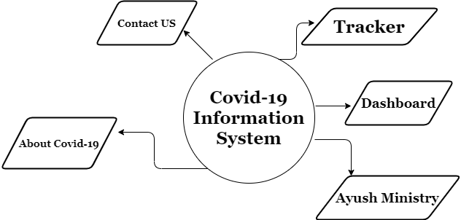

**Flowchart**

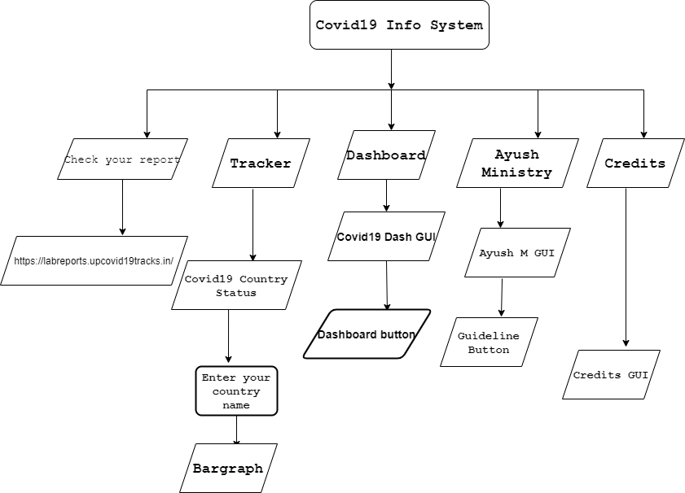

**Modules Used**

**Tkinter:-**

Tkinter is the standard GUI library for Python. Python when combined with Tkinter provides a fast and easy way to create GUI applications.

The [tkinter](https://docs.python.org/3/library/tkinter.html#module-tkinter) package (“Tk interface”) is the standard Python interface to the Tk GUI toolkit.

**Webbrowser:-**

The [webbrowser](https://docs.python.org/3/library/webbrowser.html#module-webbrowser) module provides a high-level interface to allow displaying Web-based documents to users.

**Covid:-**

Python package to get information regarding the novel corona virus provided by Johns Hopkins university and worldometers.info

**Matplotlib:-**

Matplotlib produces publication-quality figures in a variety of hardcopy formats and interactive environments across platforms.

**Pandas:-**

**pandas** is a Python package that provides fast, flexible, and expressive data structures designed to make working with structured (tabular, multidimensional, potentially heterogeneous) and time series data both easy and intuitive.

**Functions Created**

Tracker() Function:-

This function is created to retrieve data from show_data function and it is linked to the Tracker button.

Show_data():-

This function is created to scrape data from worldometer.info about current coronavirus disease and return it to the user in a new window and in the form of bar graph. It takes the name of country by the user and search for the related records if any.

Dash() Function:-

This function is used to hold the dash GUI window in this program and it is linked to the dash bar button on the homepage.

Dashbar():-

This function is created to open the desired link using webbrowser module. This function will take you to the WHO site where user can see all data of covid19 at its ease.

Ayurveda() Function:-

This function is created for displaying the GUI of Ayurveda Ministry created and will take you to a new window.

Guideline() Function:-

This function is created to retrieve data of “ayurvedacollege.com” with the help of webbrowser function it directs the user to the desired webpage.

Report() Function:-

This function is created to retrieve the covid19 antigen report from upcovid19track.in this function is linked to get report button on the homepage.It directs you to the desired webpage also.

Credit() Function:-

This function is created for GUI of credit page it contains the code of this page as well and is linked to the credits button on the homepage.

Program Code

from tkinter import *

import webbrowser

import covid

import tkinter as tk

import matplotlib.pyplot as plt

import pandas as pd

#gui for main window

root = Tk()

root.title("Coronavirus info system")

root.geometry('1920x1080+0+0')

root.configure(*bg*='darkorange')

root.iconbitmap('coronavirus.ico')

randomframe=Frame(root,*borderwidth*=6,*bg*="darkorange",*relief*=GROOVE)

randomframe.pack(*side*=TOP,*fill*="x")

#Label For main window

Introlabel = Label(randomframe,*text*='Coronavirus Info System',

*font*=('Times', 40, 'italic bold '),*bg*="darkorange")

Introlabel.config(*anchor*=CENTER)

Introlabel.pack(*fill*=BOTH)

label2 = Label(randomframe, *text*='An Initiative By City International School',

*font*=('Arial', 15),

*bg*='darkorange')

label2.config(*anchor*=CENTER)

label2.pack(*pady*=5)

label2.pack()

*def* tracker():

*def* show_data():

        data = covid.Covid()

        country_name = e1.get()

        status = data.get_status_by_country_name(country_name)

        Active = status['active']

        e2.insert(0,Active)

        Death = status['deaths']

        e3.insert(0, Death)

        Confirm = status['confirmed']

        e4.insert(0, Confirm)

        Recover = status['recovered']

        e5.insert(0, Recover)

        print(status)

        # intialise data of lists.

        data = {'id': status['id'],

            'Country': status['country'],

            'Confirmed': status['confirmed'],

            'Active': status['active'],

            'Deaths': status['deaths'],

            'Recovered': status['recovered'],

            'Latitude': status['latitude'],

            'Longitude': status['longitude'],

            'Last_Updated': status['last_update']

            }

        # Create DataFrame

        df = pd.DataFrame(data, *index*=[0])

        # Print the output.

        print(df)

        cadr = {

        key:status[key]

        for key in status.keys() & {"confirmed","active","deaths","recovered"}

        }

        n = *list*(cadr.keys())

        v = *list*(cadr.values())

        plt.title("Country")

        plt.bar(range(len(cadr)),v,*tick_label*=n,*label*=('active'))

        plt.xlabel('x-labels')

        plt.ylabel('Data')

        plt.plot(range(len(cadr)))

        plt.show()

    master = tk.Tk()

    master.title('Covid-19 country status ')

    master.configure(*bg*='darkorange')

    tk.Label(master,*text*="COVID-19 COUNTRY STATUS" ,*padx*=50,*bg*='darkorange').grid(*row*=0)

    tk.Label(master, *text*="Enter your Country name : -",*bg*='darkorange').grid(*row*=2)

    e1 = tk.Entry(master)

    e1.grid(*row*=2, *column*=3)

    tk.Button(master,*text*='Show', *command*=show_data).grid(*row*=5,

*column*=3,

*sticky*=tk.W,

*pady*=4)

    tk.Label(master, *text*="Active Cases : -",*bg*='darkorange').grid(*row*=8)

    e2 = tk.Entry(master)

    e2.grid(*row*=8, *column*=3)

    tk.Label(master, *text*="Death Cases : -",*bg*='darkorange').grid(*row*=9)

    e3 = tk.Entry(master)

    e3.grid(*row*=9, *column*=3)

    tk.Label(master, *text*="Confirmed Cases : -",*bg*='darkorange').grid(*row*=10)

    e4 = tk.Entry(master)

    e4.grid(*row*=10, *column*=3)

    tk.Label(master, *text*="Recovered Cases : -",*bg*='darkorange').grid(*row*=11)

    e5 = tk.Entry(master)

    e5.grid(*row*=11, *column*=3)

    master.mainloop()

#function for dasboard gui

*def* dash():

*def* dashbar():

        webbrowser.open("https://covid19.who.int/")

    who = Tk()

    who.title("Coronavirus info system")

    who.geometry('1400x720')

    who.configure(*bg*='darkorange')

    who.iconbitmap('coronavirus.ico')

    frame1=Frame(who,*borderwidth*=8,*bg*="darkorange",*relief*=SUNKEN)

    frame1.pack(*side*=TOP,*fill*="x")

    label5=Label(frame1,*text*="Covid-19 Dashboard",*font*=("Times", 40,"bold italic underline"),*bg*="darkorange")

    label5.pack(*pady*=10)

    frame2=Frame(who,*borderwidth*=5,*relief*=GROOVE,*bg*="lightcoral")

    frame2.pack(*side*=LEFT,*fill*="y",*pady*=50)

    label8=Label(frame2,*text*="The World Health Organization (WHO) on March 11 declared COVID-19 a pandemic, pointing\n to the over 118,000 cases of the coronavirus illness in over 110 countries and\nterritories around the world and the sustained risk of further global spread.\n“This is not just a public health crisis, it is a crisis that will touch every sector,”\nsaid Dr. Tedros Adhanom Ghebreyesus, WHO director-general, at a media\nbriefing. “So every sector and every individual must be involved in the fights.”\nAn epidemic refers to an uptick in the spread of a disease within a specific\ncommunity. By contrast, the WHO defines a pandemic as global spread of a new \ndisease, though the specific threshold for meeting that criteria is fuzzy.\nThe term is most often applied to new influenza strains, and the CDC says\nit’s used when viruses “are able to infect people easily and spread from person to\nperson in an efficient and sustained way” in multiple regions. The declaration\nrefers to the spread of a disease, rather than the severity of the illness it causes  ",

*font*=('Times', 15 ,'italic bold'),

*bg*='lightcoral',*justify*=LEFT)

    label8.pack(*pady*=10)

    dashbutton=Button(frame2,*fg*="black",*relief*=RIDGE,*text*="COVID19 DASHBAR",*font*=('Times',20,'bold underline italic'),*bg*="olive",*width*=20,*height*=2,*command*=dashbar)

    dashbutton.pack(*pady*=20)

    pframe=Frame(who,*borderwidth*=5,*relief*=SUNKEN,*bg*='olive')

    pframe.pack(*side*=TOP,*fill*="x",*padx*=10,*pady*=50)

    dashlab=Label(pframe,*text*="To prevent infection and to slow transmission of COVID-19,\ndo the following:",

*font*=('Helvetica',15,'bold italic underline'),*bg*="olive",*justify*=LEFT)

    dashlab.pack()

    ppframe=Frame(who,*bg*='darkorange',*borderwidth*=4)

    ppframe.pack(*side*=TOP,*fill*="both",*padx*=10)

    dashlab2=Label(ppframe,*text*="●Wash your hands regularly with soap and water, or clean\nthem with alcohol-based hand rub.\n\n●Maintain at least 1 metre distance between you and people \ncoughing or sneezing.\n\n●Avoid touching your face.\n\n●over your mouth and nose when coughing or sneezing.\n\n●Stay home if you feel unwell.\n\n●Refrain from smoking and other activities that weaken the lungs.\n\n●Practice physical distancing by avoiding unnecessary\ntravel and staying away from large groups of people.",

*font*=('Times',15,'italic'),*bg*="darkorange",*justify*=LEFT)

    dashlab2.pack()

    who.mainloop()

*def* ayurved():

*def* guideline():

        webbrowser.open("https://www.ayurvedacollege.com/blog/corona-virus-precautions-and-guidelines/")

    ayur = Tk()

    ayur.title("Coronavirus info system")

    ayur.geometry('1400x720')

    ayur.configure(*bg*='olive')

    ayur.iconbitmap('coronavirus.ico')

    ayurframe=Frame(ayur,*borderwidth*=5,*bg*="darkorange",*relief*=GROOVE)

    ayurframe.pack(*side*=TOP,*fill*="x")

    ayurlabel=Label(ayurframe,*text*="Ayurveda Guidelines",*font*=('Times',40,'bold italic'),*bg*='darkorange')

    ayurlabel.pack()

    ayurframe2=Frame(ayur,*borderwidth*=4,*bg*="darkorange",*relief*=SUNKEN)

    ayurframe2.pack(*side*=TOP,*pady*=20)

    ayurlabel2=Label(ayurframe2,*text*="Ayurveda, being the science of life, propagates the gifts of nature in maintaining\nhealthy and happy living. Ayurveda’s extensive knowledge base on preventive \ncare, derives from the concepts of “Dinacharya” - daily regimes and “Ritucharya”\n- seasonal regimes to maintain healthy life. It is a plant-based science. The \nsimplicity of awareness about oneself and the harmony each individual can achieve \nby uplifting and maintaining his or her immunity is emphasized across Ayurveda’s \nclassical scriptures.\n\nMinister of State (MoS) for AYUSH, Shripad Y Naik  said that Prime Minister\nNarendra Modi has established a task force for scientific validation of Ayurveda\nand traditional medicine formulas through research institutions like ICMR, to\nbe used in the treatment of COVID-19.",

*font*=('Times', 15 ,'italic bold'),

*bg*='darkorange',*justify*=LEFT)

    ayurlabel2.pack(*pady*=10)

    ayurframe3=Frame(ayur,*borderwidth*=4,*bg*='darkorange',*relief*=SUNKEN)

    ayurframe3.pack(*side*=TOP)

    ayurlabel3=Label(ayurframe3,*text*="California College",*font*=('Helvetica',20,'bold underline italic')

                     ,*bg*='darkorange')

    ayurlabel3.pack()

    ayurframe4=Frame(ayur,*borderwidth*=3,*relief*=SUNKEN,*bg*='darkorange')

    ayurframe4.pack()

    ayurlabel4=Label(ayurframe4,*text*="Among the countries with the highest death toll are some of the most populour countries in \nthe world such as the US, Brazil, and Mexico.You can see\nthe ayurveda guidlines by california college for coronavirus by clicking the button below:"

                     ,*font*=('Times',17,'italic'),*bg*='darkorange',*justify*=CENTER)

    ayurlabel4.pack()

    ayurbutton=Button(ayurframe4,*borderwidth*=3,*fg*="black",*relief*=GROOVE,*text*="Ayurveda Guidelines",*font*=('Times',15,'bold underline italic'),*bg*="olive",*width*=20,*height*=2,*command*=guideline)

    ayurbutton.pack(*pady*=10)

    ayur.mainloop()

*def* credit():

    cred = Tk()

    cred.title("Coronavirus info system")

    cred.configure(*bg*='darkblue')

    cred.iconbitmap('coronavirus.ico')

    cred.geometry("900x400")

    credframe=Frame(cred,*borderwidth*=3,*relief*=GROOVE,*bg*='yellow')

    credframe.pack(*side*=TOP,*fill*="x",*padx*=10)

    credlabel=Label(credframe,*text*='Coronavirus info system',*font*=('Helvetica',20,'bold'),

*bg*='yellow',*fg*='purple')

    credlabel.pack()

    credframe2=Frame(cred,*borderwidth*=2,*relief*=SUNKEN,*bg*='yellow')

    credframe2.pack(*side*=TOP,*pady*=20,*padx*=10)

    credlabel2=Label(credframe2,*text*="Designed By:-",*font*=('Times',20,'underline'),*bg*='yellow',*fg*='purple')

    credlabel2.pack()

    credframe3=Frame(cred,*borderwidth*=5,*relief*=SUNKEN,*bg*='darkblue')

    credframe3.pack(*side*=TOP,*fill*="y",*pady*=10,*padx*=10)

    credlabel3=Label(credframe3,*text*="● Enal Singh (12-Science)\n\n ● Danish Khan (12-Science)",*font*=('Times',17),*bg*='darkblue',*fg*='yellow')

    credlabel3.pack()

    credframe4=Frame(cred,*borderwidth*=5,*relief*=SUNKEN,*bg*='yellow')

    credframe4.pack(*side*=TOP,*fill*="y",*pady*=9,*padx*=10)

    credlabel4=Label(credframe4,*text*="CITY INTERNATIONAL SCHOOL\nLUCKNOW 226016",*font*=('Times',17),*bg*='yellow',*fg*='purple',*justify*=CENTER)

    credlabel4.pack()

    credframe5=Frame(cred,*borderwidth*=5,*relief*=SUNKEN,*bg*='darkblue')

    credframe5.pack(*side*=TOP,*fill*="y",*pady*=9,*padx*=10)

    credlabel5=Label(credframe5,*text*="SUBIMTTED TO:-Rachna Ma'am",*font*=('Times',17),*bg*='darkblue',*fg*='yellow',*justify*=CENTER)

    credlabel5.pack()

    cred.mainloop()

f1=Frame(root,*borderwidth*=6,*bg*="darkorange")

f1.pack(*side*=TOP,*fill*="y",*pady*=10)

button=Button(f1,*fg*="red",*relief*=SOLID,*text*="Tracker",*font*=('Times',15,'bold underline italic'),*bg*="green",*width*=20,*height*=2,*activebackground*="lightcoral",*activeforeground*="red",*command*=tracker)

button.pack(*side*=LEFT,*padx*=35)

button2=Button(f1,*fg*="blue",*relief*=SOLID,*text*="Dashboard",*font*=('Times',15,'bold underline italic'),*bg*="green",*width*=20,*height*=2,*activebackground*="lightcoral",*activeforeground*="blue",*command*=dash)

button2.pack(*side*=LEFT,*padx*=35)

button3=Button(f1,*fg*="black",*relief*=SOLID,*text*="Ayush Ministry ",*font*=('Times',15,'bold underline italic'),*bg*="green",*width*=20,*height*=2,*activebackground*="lightcoral",*activeforeground*="green",*command*=ayurved)

button3.pack(*side*=LEFT,*padx*=35)

button4=Button(f1,*fg*="brown",*relief*=SOLID,*text*="Credits",*font*=('Times',15,'bold underline italic'),*bg*="green",*width*=20,*height*=2,*activebackground*="lightcoral",*activeforeground*="brown",*command*=credit)

button4.pack(*side*=LEFT,*padx*=35)

*def* report():

    webbrowser.open("https://labreports.upcovid19tracks.in/")

flabel=Frame(root,*borderwidth*=6,*bg*="orange",*relief*=SUNKEN)

flabel.pack(*side*=LEFT,*fill*="both",*pady*=0)

label3= Label(flabel,*text*='What Is Coronavirus ?',

*font*=('Helvetica',30,'bold'),

*bg*='orange')

label3.pack(*pady*=10)

label3.pack()

label4 = Label(flabel, *text*='Coronavirus disease (COVID-19) is an infectious disease caused by a newly discovered coronavirus.\nMost people infected with the COVID-19 virus will experience mild to moderate respiratory illness and\n recover without requiring special treatment.  Older people, and those with underlying medical problems\n like cardiovascular disease, diabetes, chronic respiratory disease, and cancer are more likely to \ndevelop serious illness.The best way to prevent and slow down transmission is\n be well informed about the COVID-19 virus, the disease it causes and how it spreads. Protect\n yourself and others from infection by washing your hands or using an alcohol\n based rub frequently and not touching your face. The COVID-19 virus spreads primarily through droplets\n of saliva or discharge from the nose when an infected person coughs or sneezes, so it’s important\n that you also practice respiratory etiquette (for example, by coughing into a flexed elbow).\nAt this time, there are no specific vaccines or treatments for COVID-19. However, \nthere are many ongoing clinical trials evaluating potential treatments. \nWHO will continue to provide updated information as soon as clinical findings become available.',

*font*=('Times', 15 ,'italic bold'),

*bg*='orange',*justify*=CENTER)

label4.pack(*pady*=10)

label4.pack()

label6=Label(flabel,*text*="!!COVID-19 Vaccine !!",*font*=('Helvetica',20,'bold underline'),*bg*="orange")

label6.pack(*pady*=10)

label7=Label(flabel,*text*="There are currently more than 100 COVID-19 vaccine candidates under development,with a number of these in the human\ntrial phase. WHO is working in collaboration with scientists, business, and global health organizations through the ACT\nAccelator speed up the pandemic response. When a safe and effective vaccine is found, COVAX (led by WHO, GAVI and  CEPI)\nwill facilitate the equitable access and distribution of these vaccines to protect people in all countries. \nPeople most at risk will be prioritized.",

*font*=('Times', 15 ,'italic bold'),

*bg*='orange',*justify*=CENTER)

label7.pack(*pady*=20)

reportbutton=Button(flabel,*borderwidth*=3,*relief*=RIDGE,*text*="Check Your COVID Report",*font*=('Times',15,'bold underline italic'),*bg*="orange",*fg*="red",*width*=30,*height*=2,*command*=report)

reportbutton.pack(*pady*=10)

photoframe=Frame(root,*borderwidth*=5,*relief*=SUNKEN)

photoframe.pack(*side*=BOTTOM,*fill*="y",*padx*=5)

photo=PhotoImage(*file*="warriors.png")

photolabel=Label(photoframe,*image*=photo)

photolabel.pack()

photoframe2=Frame(root,*borderwidth*=5,*relief*=SUNKEN)

photoframe2.pack(*side*=RIGHT,*fill*="y",*padx*=5,*pady*=3)

photo2=PhotoImage(*file*="distancing.png")

photolabel2=Label(photoframe2,*image*=photo2)

photolabel2.pack()

root.mainloop()

Program Output

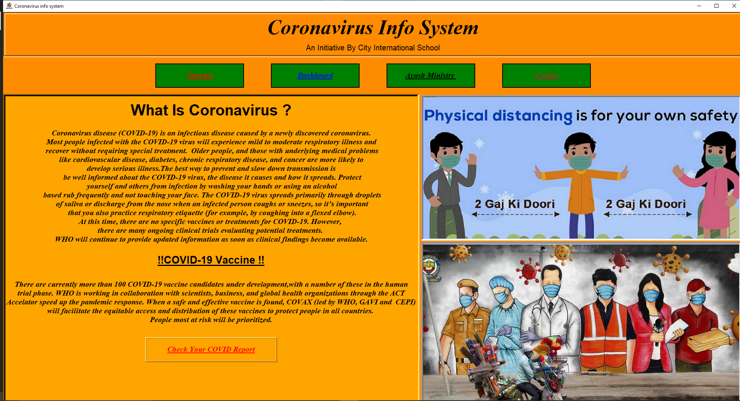

Screenshot1:-Homepage

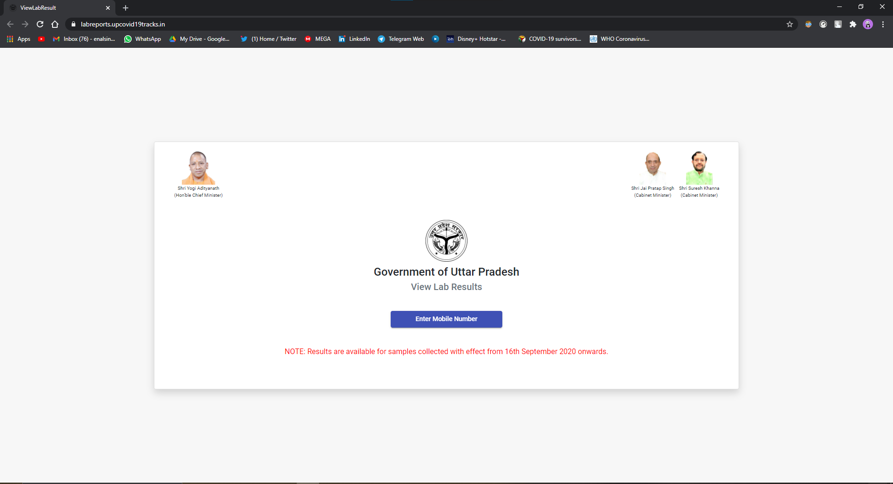

Screenshot2:- Site for checking report

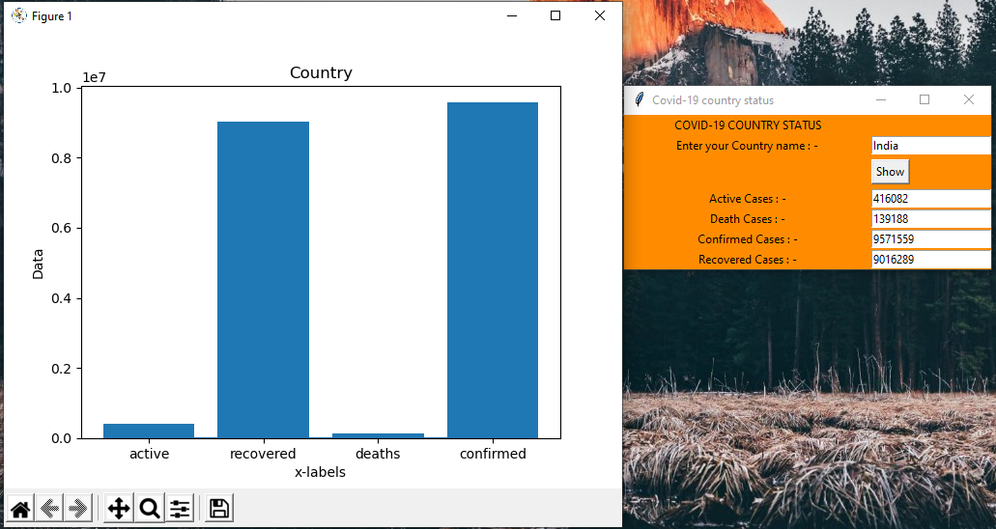

Screenshot3:-Gui for tracking covid19

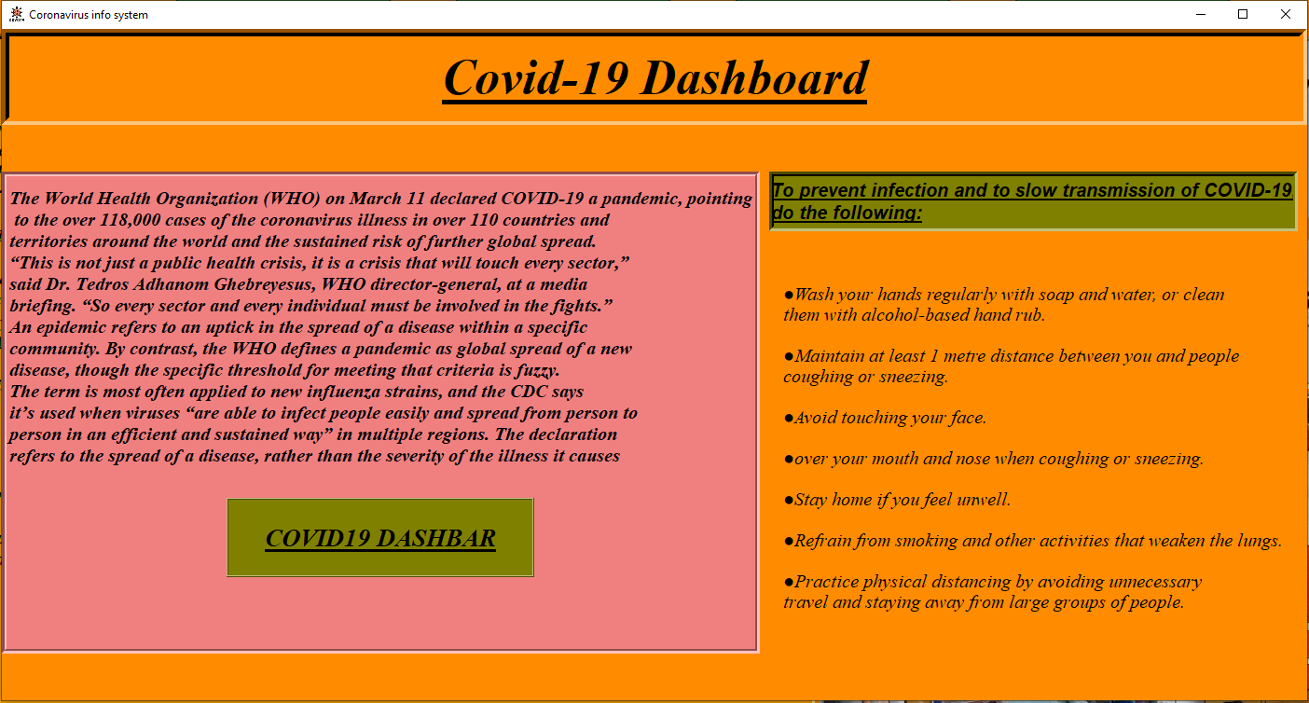

Screenshot4:-Gui for dasboard

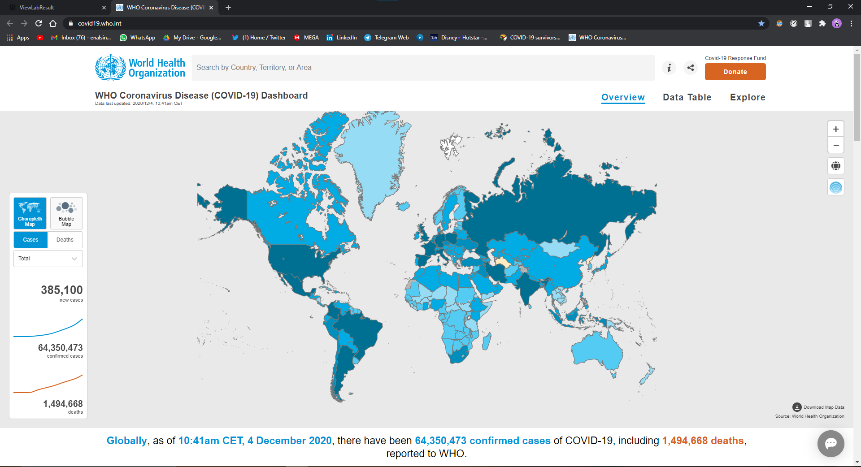

Screenshot5:- WHO Dashboard

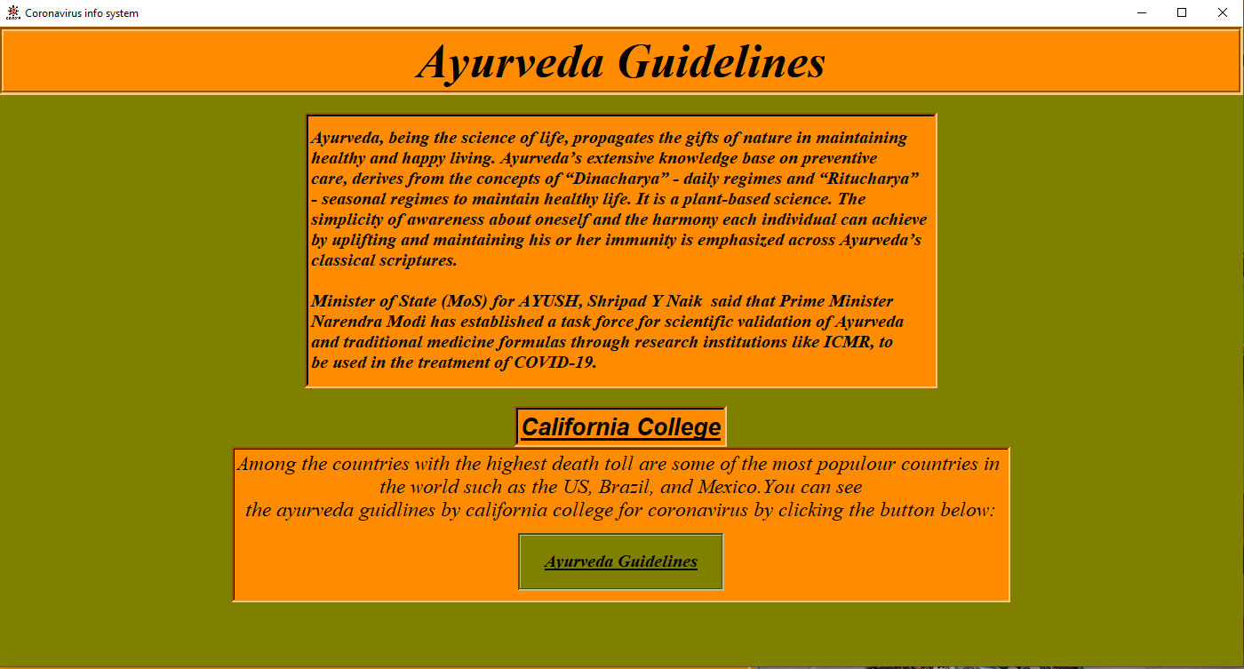

Screenshot6:-Gui for Ayurved guideline

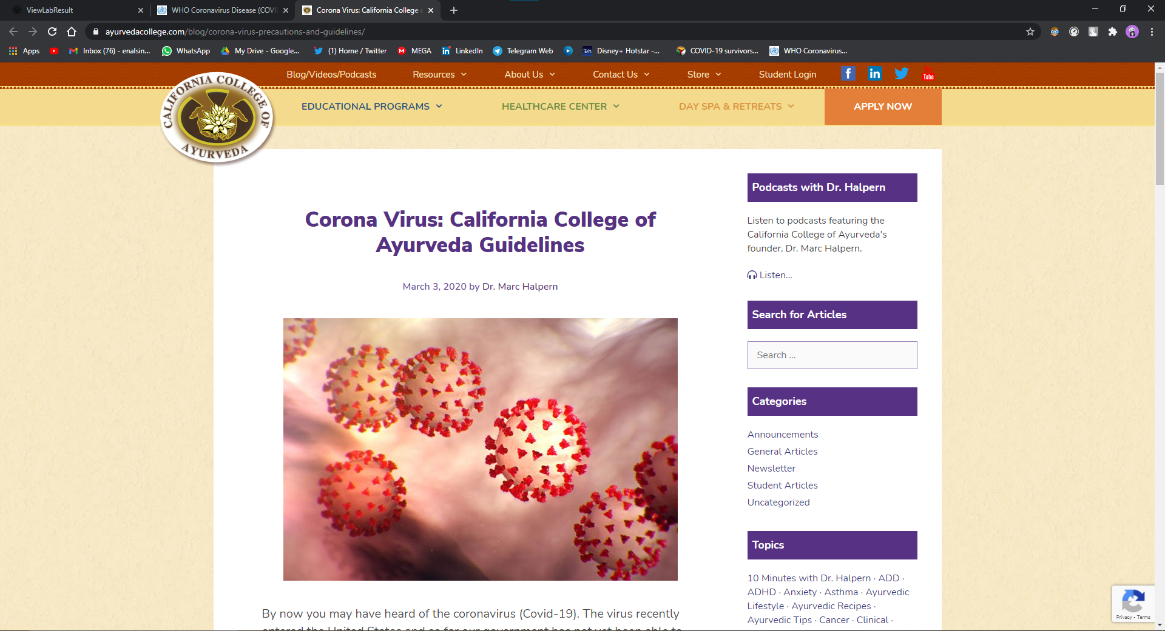

Screenshot7:- COA official guidlines

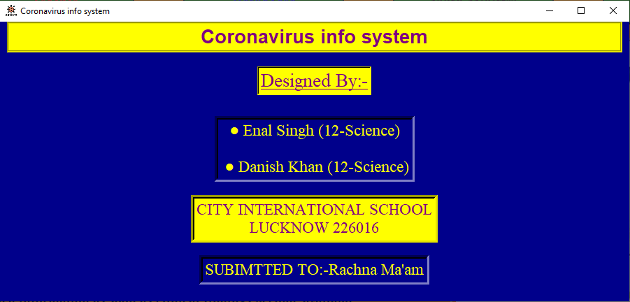

Sceenshot8:-Gui for credits window

Conclusion

Python is very useful, important and easy to learn programming language.

We tried to implement all the topics taught in the class although we stuck in some situations but we figured it how to solve them with the help of our teacher and our dear friend.

This project can be scaled out on commercial level. Some of the features can be added like

Customization of design on user end and many more and can include many window like info of nearest health centers according to your location and many more..

Bibliography

<https://www.google.com/>

<https://www.youtube.com/>

<https://stackoverflow.com/>

<https://github.com/>

<https://www.w3schools.com/>

https://pypi.org/